


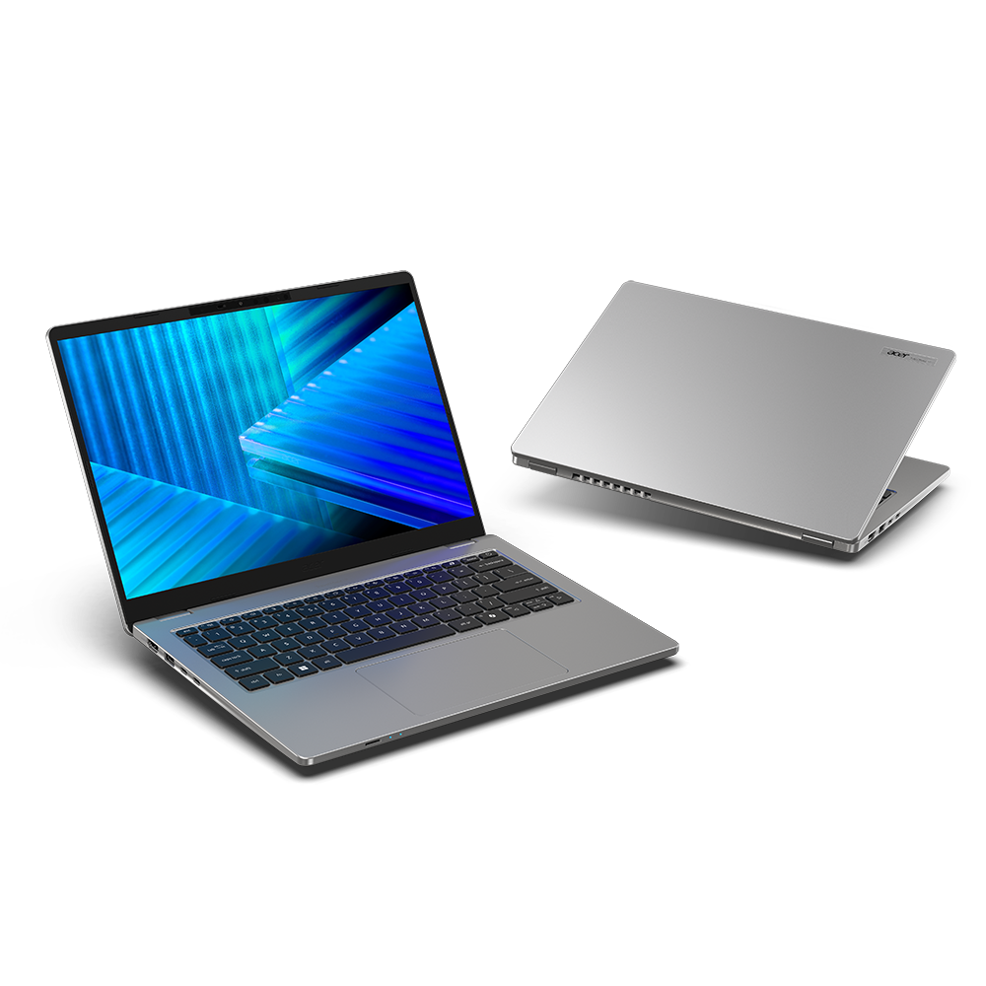

TravelMate P2 14

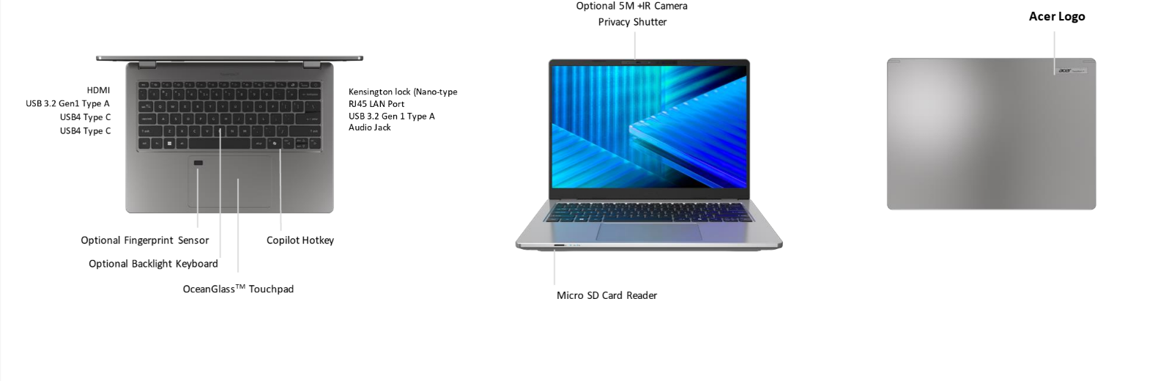
SPECIFICATIONS Acer TravelMate P2 14 TMP214-44 | TMP214-44-TCO
Acer NITRO V 16S ANV16S-71
Operating System |  | Windows 11 Pro  Windows 11 Home
CPU and Chipset |  | AMD Ryzen™ 5 PRO 230 | AMD Ryzen™ 7 PRO 250
Memory |  | Dual-channel DDR5 SDRAM support | Memory Frequency: Up to 5600 MT/s | Up to 32 GB of DDR5 system memory using two soDIMM modules
Display |  | 14.0" display with IPS (In-Plane Switching) technology, WUXGA 1920 x 1200, Acer ComfyView™ LED-backlit TFT LCD, supporting 120Hz refresh rate.  - 16:10 aspect ratio, color gamut NTSC 45%  - Wide viewing angle up to 170 degrees  - Mercury free, environment friendly |  |  | 14.0" display with IPS (In-Plane Switching) technology, WUXGA 1920 x 1200, Acer ComfyView™ LED-backlit TFT LCD, supporting 120Hz refresh rate.  - 16:10 aspect ratio, color gamut sRGB 100%  - Wide viewing angle up to 170 degrees  - Mercury free, environment friendly
Graphics |  | AMD Radeon™ 780M Graphics  Graphics Special Technology:  •VP9, H.264, H.265 8bit/10bit decode  • H.264, H.265 8bit video encode | AMD Radeon™ 760M Graphics  Graphics Special Technology:  •VP9, H.264, H.265 8bit/10bit decode  • H.264, H.265 8bit video encode
Audio |  | DTS® Audio, featuring optimized bass response and micro-speaker distortion prevention  Acer TrueHarmony Technology for lower distortion, wider frequency range, headphone-like audio and powerful sound by Acer Ultra Boost Stereo Speaker Module  Compatible with Cortana with Voice |  | Acer Purified.Voice technology with AI noise reduction with dual-mic array built-in microphones. Features include far-field pickup, dynamic noise reduction through neural network, adaptive beam forming, and pre-defined personal and conference call modes.  High SNR DAC with 2.1 Vrms out capability and can driver high impedance headphone (up to 600 ohm)
Storage |  | Solid state drive (1 slot): 256 GB / 512 GB / 1 TB, PCIe Gen4, 16 Gb/s, NVMe
Webcam |  | UFC with Double T-Type USB 5M + IR Camera | Compatible with Windows only | 2880 x 1800 Resolution | 1800p 5M Video at 30 FPS with Temporal Noise Reduction | Staggered High Dynamic Range (SHDR) | Dual Mic (33 mm + 33 mm) | 86 x 3.2 (4.2) x 3 mm | Blue glass lens | IR 940nm  UFC with Double T-Type USB FHD Camera | Compatible with Windows only | 1920 x 1080 resolution | 1080p HD video at 30 fps with Temporal Noise Reduction | 86 x 3.2 (4.2) x 3 mm | Blue glass lens | Dual Mic (33 mm + 33 mm)
Wireless and Networking |  | WLAN:  • Wi-Fi 7 Wireless LAN  • 802.11 a/b/g/n/ac/ax/be  • Band: 2.4 GHz, 5 GHz, and 6 GHz  • 2x2 MU-MIMO technology  • GT Booster - AI Flow | LAN:  • Gigabit Ethernet, Wake-on-LAN ready  WPAN:  Supports Bluetooth® 5.4 or above for Wi-Fi 7 wireless card.  Supports Bluetooth LE Audio (LC3).
Security |  | Acer ProShield Plus security manager includes: Data Protection: File & Folder Encryption and Decryption, Personal Security Drive | Data Removal: File Shredding | Security Alert: Invalid Access Alert, Security Report  Discrete Trusted Platform Module (TPM) solution | Kensington lock (Nano-type)
Dimensions and Weight |  | Dimensions  314 (W) x 228 (D) x 17.9 (H) mm (12.36 x 8.98 x 0.7 inches) with LAN port |  | Weight  1.37 kg (3.02 lbs.) with 3-cell battery pack, WUXGA display
Power Adapter and Battery |  | Power Adapter  100 W PD PCR 50%, TCO 10.0 AC adapter | 5 V / 3 A or 9 V / 3 A or 12 V / 3 A or 15 V / 3 A or 20 V / 5 A as output power | 108.0 (W) x 56.0 (D) x 26.5 (H) mm | 296 g ± 5% with 150 cm DC cable | Black color with Acer logo | Brick type AC pins | Paper sleeve packaging  65 W PD PCR 50%, TCO 10.0 AC adapter | 5 V / 3 A or 9 V / 3 A or 12 V / 3 A or 15 V / 3 A or 20 V / 3.25 A as output power | 90.0 (W) x 51.0 (D) x 28.5 (H) mm | 192 g ± 10% with 150 cm DC cable | Black color with Acer logo | Brick type AC pins | Paper sleeve packaging |  | Battery  53 Wh 3-cell Li-ion battery | Supports Fast Charging technology | For models with WUXGA Panel + SSD | Battery life: Up to 9 hours (based on MobileMark® 2030 test results) | Up to 14 hours (based on video playback test results) | Up to 10.5 hours (based on web browsing test results)  65 Wh 3-cell Li-ion battery | Supports Fast Charging technology | For models with WUXGA Panel + SSD | Battery life: Up to 11 hours (based on MobileMark® 2030 test results) | Up to 17 hours (based on video playback test results) | Up to 12.5 hours (based on web browsing test results)
Input and Control |  | Keyboard  80-/81-/84-key Acer backlight keyboard layout with international language support, light-weight and embedding LED indicators for Caps-Lock and MIC mute fuction | Good typing feeling with 1.6mm long keystroke distance  Control Keys  Copilot Key | TravelMate Sense Key |  | Touchpad  Multi-gesture secure touchpad, supporting two-finger scroll; pinch; gestures to open Cortana, Action Center, multitasking; Fingerprint application commands | Windows Hello Certification | Microsoft Precision Touchpad certification | * OceanGlass™ Touchpad  Multi-gesture touchpad, supporting two-finger scroll; pinch; gestures to open Cortana, Action Center, multitasking; application commands | Microsoft Precision Touchpad certification | Moisture resistant | OceanGlass™ Touchpad  (Notes: Spill Resistant Keyboard based on MIL-STD-810H Method506.6 Procedure III Drip test)
Windows Desktop Apps |  | In-House Applications  Acer LiveArt | Acer ORD Service | Acer QuickPanel | TravelMate Sense |  | Tools  Acer My Key Application
Warranty |  | One-year International Travelers Warranty (ITW)
Disclaimers
• | Specifications vary depending on model.
• | Shared system memory may be allocated to support graphics, depending on system memory size and other factors. Actual system memory available to the operating system will be reduced by any memory used by the graphics solution and resources required by the operating environment.
• | Memory speed may vary, depending on the CPU, chipset or memory fitted.
• | All brands and product names mentioned herein include trademarks of their respective companies and are used solely to describe or identify the products.
• | 1 GB is 1 billion bytes. Actual formatted capacity is less and may vary depending on preloaded materials and operating environment. Acer Recovery Management uses a portion of the stated hard disk capacity as dedicated backup space.
• | Minor variations in system dimensions are possible due to the manufacturing process.
• | Weight may vary depending on product configuration, vendor components, manufacturing variability, and selected options.
• | Listed battery life is based on testing using video playback. The test clip loops and continues to run, without interruption or any other inputs, until the battery is drained. Stated battery life is for comparison purpose only. Actual battery life varies by model, configuration, applications, video chip format and features used. A battery's maximum capacity decreases with time and use. Battery life test configuration: AMD Ryzen™ 5 240, AMD Radeon™ RX560X, WUXGA, SSD only, 8GB of DDR5 memory. Battery life test condition: LCD brightness 150 nits, connected headphones, WLAN off, Bluetooth off and Better Battery Mode on.
• | Listed battery life is based on testing using Web browsing. The test clip loops the loading of 50 selected websites using Microsoft Edge every 30 seconds, until the battery is drained. Stated battery life is for comparison purpose only. Actual battery life varies by model, configuration, applications, video chip format and features used. A battery's maximum capacity decreases with time and use. Battery life test configuration: AMD Ryzen™ 7 260, AMD Radeon™ RX 640, WUXGA, SSD only, 8GB of DDR5 memory. Battery life test condition: 100 nits LCD brightness, 50% speaker volume, WLAN on, Bluetooth on, no WW direct Internet connection.
• | Actual battery life may vary considerably by specifications, depending on product model, configuration, applications, power management settings, operating conditions, and features utilized. Performance variation also arises based on components in use, which includes but is not limited to the processor, RAM capacity, storage, display and resolution, etc.
• | Bundled software may vary depending on hardware configuration, OS and regional availability.
• | EPEAT® registration varies by country. See http://www.epeat.net/ for registration status for each country.
• | Specifications vary depending on model.
Product Sheet is based on TravelMate P214-44 Specifications (v1-0-0) (Preview) and TravelMate P214-44-TCO Specifications (v3-0-3) (Preview)

